MINI PROJECT REPORT

ON

StuFun

**Submitted by:**

|  |  |  |  |
| --- | --- | --- | --- |
| **Tushar**  **Gupta** | **Jalanki**  **Nayak** | **Kartik Agrawal** | **Yash Vardhan Gautam** |
| **181500760** | **181500291** | **181500311** | **181500830** |

**Department of Computer Engineering & Application**

**Institute of Engineering & Technology**



GLA University

Mathura – 281406, INDIA

2020

**CERTIFICATES**

**Tushar Gupta**

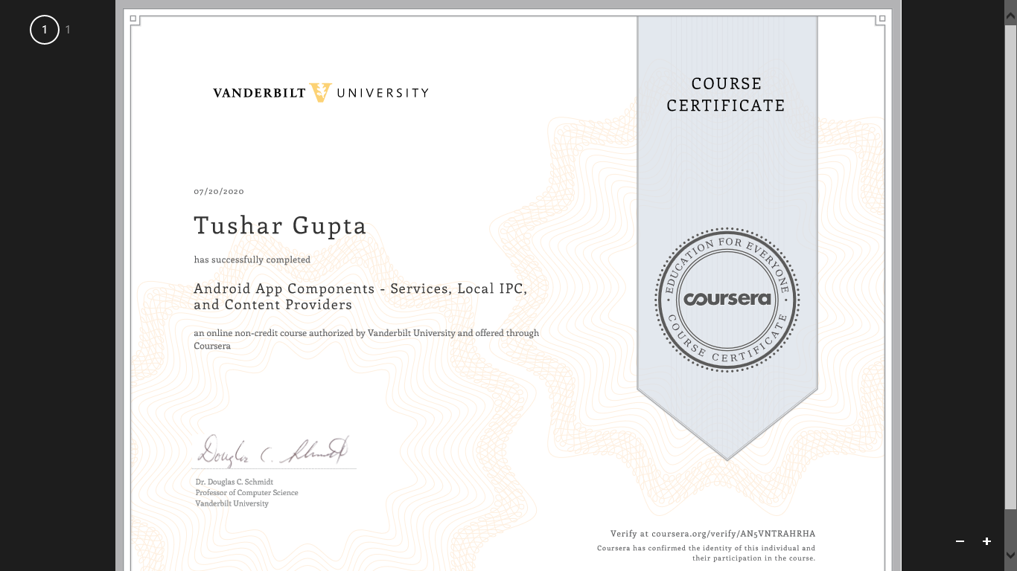

**Yash Vardhan Gautam**

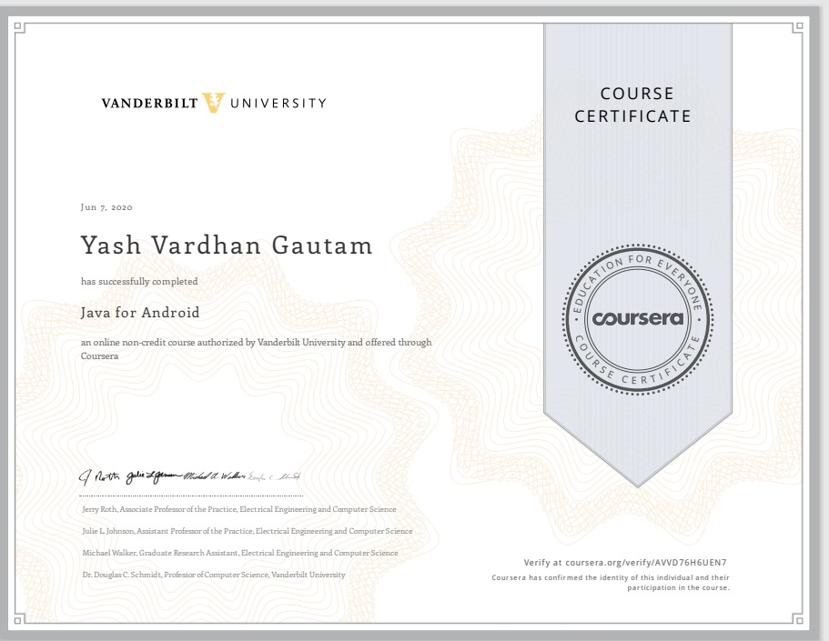

**CERTIFICATES**

**Kartik Agrawal**

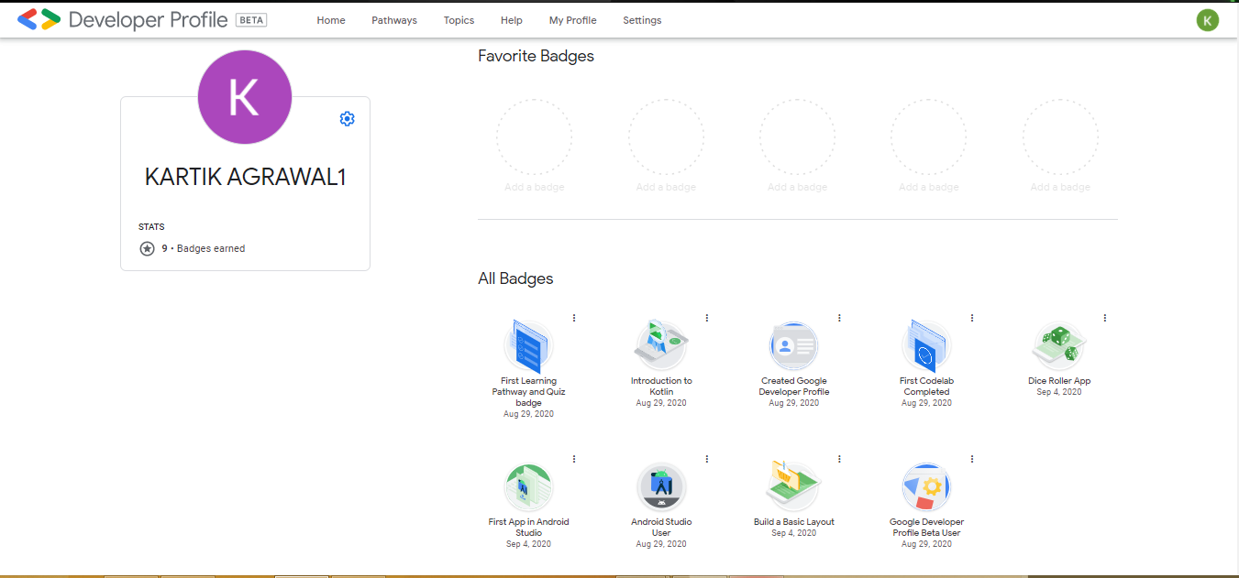

**Jalanki Nayak**

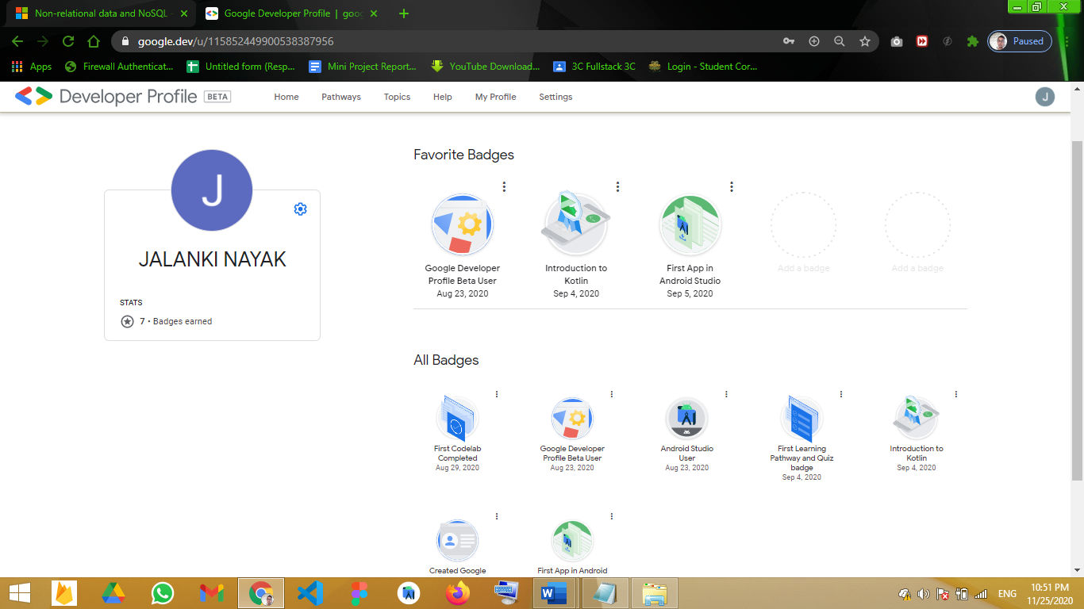

**Project Information:**

|  |  |
| --- | --- |
| Title of Project | StuFun |
| Technical Details | Hardware Requirements:  PC of minimum 4 GB RAM and 1 TB Hard disk  Software Requirements:  Android Studio (For Developing)  Figma (For Designing) |
| Project Implementation Details | Fully Implemented |
| Project Working Period | Start Date: 15 July 2020  End Date: 25 Nov 2020 |

**Summary of the Project Work:**

|  |
| --- |
| Students nowadays use WhatsApp not only as a messaging app but also as an extension of their classroom, use it not only to interact with the environment during study hours but also to share resources, connect with teachers at any given time, learn and study groups, live doubt sessions, etc. Though the current online education platform gives students the freedom to study at any time with lots of resources it lacks a sense of discipline, sociality, and status of learning. Through this project, the team hopes to build a platform that is much effective than present applications.  Android is rapidly getting famous day by day and the number of its users is increasing with every blink of an eye because it is easy to access the necessary android-based applications on smartphones and tablets in your hands. Therefore, we found this idea interesting, easy, and time-efficient to facilitate the users in this way without any difficulty. The team has created an android application which is an amalgamation of a messaging app and a classroom app. |

**ACKNOWLEDGEMENT**

On successful completion of my project thus we would take a privilege to thank the supporting manpower of our faculty members, and all my friends & colleagues with gratitude. However, we wish to make special mention of the following.

First of all, I’m are thankful for my mentor **Mr. Vaibhav Diwan** and all the friends and mentors of the CEA department under whose guidelines I was able to complete my project up to the valuable mark. I’m wholeheartedly thankful to them for giving me their value able time and attention, and for providing me a systematic way for completing my project in time.

**DECLARATION**

We hereby declare that the work which is being presented in the Mini Project**,** in partial fulfillment of the requirements for Mini Project viva voce, is an authentic record of my work carried under the mentorship of **Mr. Vaibhav Diwan.**

|  |  |
| --- | --- |
| **Name of Candidate: Tushar Gupta**  **Roll. No.: 181500760**  **Course: B. TECH CS**  **Year: 3rd Year**  **Semester: Vth Semester**  **Signature of Candidate:** | **Name of Candidate: Kartik Agrawal**  **Roll. No.: 181500311**  **Course: B. TECH CS**  **Year: 3rd Year**  **Semester: Vth Semester**  **Signature of Candidate:** |
| **Name of Candidate: Jalanki Nayak**  **Roll. No.: 181500291**  **Course: B. TECH CS**  **Year: 3rd Year**  **Semester: Vth Semester**  **Signature of Candidate:** | **Name of Candidate: Yash Vardhan Gautam**  **Roll. No.: 181500830**  **Course: B. TECH CS**  **Year: 3rd Year**  **Semester: Vth Semester**  **Signature of Candidate:** |

**ABSTRACT**

With a market cap of around $2 billion by 2021, online education is now one of the fastest-growing industries in India. The major reasons being a tech revolution providing cheap internet and a large sector of the population that has high aspirations but low incomes.

Students nowadays use WhatsApp not only as a messaging app but also as an extension of their classroom, use it not only to interact with the environment during study hours but also to share resources, connect with teachers at any given time, learn and study groups, live doubt sessions, etc. Though the current online education platform gives students the freedom to study at any time with lots of resources it lacks a sense of discipline, sociality, and status of learning. Through this project, the team hopes to build a platform that is much effective than present applications. The team has created an android application which is an amalgamation of a messaging app and a classroom app. As android is the most used OS in India our application would be having a wider reach and also because of its ease of usage. The app would be giving different roles to Teachers and Students with the use of two user strategy. To add a sense of real classrooms many features like quizzes, polls, QnA has been added too.

**CONTENTS**

|  |  |
| --- | --- |
| Certificate | ii |
| Synopsis | iii |
| Acknowledgment | iv |
| Declaration | v |
| Abstract | vi |

1. **Introduction ...…………………………………………….……………………...…….3-8**
   1. Motivation …….……………...………………………………….…………………...3-4
   2. Objective………….…………...……………………………………………………...4-5
   3. Technologies Used….………………………………………………………………...5-8
      1. Java……………………………………….……….................................5-6
      2. XML…………………………………….………………………………6-7
      3. Firebase Database………………….…………………......……………..7-8
      4. Android Studio…………………….…………………….…………….….8
2. **Software Requirement analysis ...……………………………………………………9-11**
   1. Problem Statement…………………………….……………….…...…………………..9
   2. Define Module and Functionalities…………….………………...………………...10-14
      1. Application description ………….………………………………......10-12
      2. Functional Requirement……………………………………………...….13
      3. Non-Functional Requirement….………………………………………...14
3. **Software Design ...…………………………………………………...…………...….15-29**
   1. Data Flow Diagram ………………………….…………………………...…………. 15
   2. UML Diagram …..……………………………….……………………...…………16-22
      1. Class Diagram …...………………...…………………...…………….….16
      2. Activity Diagram …………………………………………………….17-21
      3. Use Case Diagram………….….……………………....……………...…22
   3. Database Design …...………………………………………...……...……………..23-29
      1. Er Diagram ………………………………….…………………………...23
      2. Table Description …..………………………….…………………….24-29
4. **Implementation and User Interface …………………………..…………………....25-42**
5. **Reference ….……………………………………………….……………………….…...43**

**INTRODUCTION**

There are numerous active chatting apps worldwide, among those WhatsApp scores the highest rank around the globe. WhatsApp was founded by Jan Koum and Brian Acton who had previously spent 20 years combined at Yahoo. WhatsApp joined Facebook in 2014 but continues to operate as a separate app with a laser focus on building a messaging service that works fast and reliably anywhere in the world. As per the record, it serves 2 billion users worldwide. WhatsApp is available in 180 countries and 60 different languages. Due to its many features, it is covering large users.

It provides us many features to communicate and share pieces of stuff with friends and family easily and cost-efficiently. WhatsApp has many features but Groups in these Chatting Applications are used for informal chats and fun. Using these groups for educational purposes is not preferable and has many limitations. To overcome the limitations discussed above, an application needs to be made which contains the features of both the chatting application and classroom. StuFun is a Chatting Application that incorporates the features of the Classroom which makes it convenient for both fun and educational purposes.

* 1. **MOTIVATION**

Android is rapidly getting famous day by day and the number of its users is increasing with every blink of an eye because it is easy to access the necessary android-based applications on smartphones and tablets in your hands. Therefore, we found this idea interesting, easy, and time-efficient to facilitate the users in this way without any difficulty. As we all know in today’s digital world social messaging apps like WhatsApp, Telegram, Messenger, etc. are the most popular way to connect with friends, family, and businesses. These Apps allow us to do personal chats with one particular person or we can create groups where we can chat with a lot of people. Many businesses are now being run on WhatsApp as a result many official and professional work is now being done on such apps.

Nowadays such groups are also used for educational purposes where teachers create groups of their classes for announcements and can share information like class activities. But using these groups for educational purposes has some limitations. Students can be added only with their mobile numbers which are generally of their parents. Whenever a student is having some doubt regarding a topic and he/she wants to discuss it with the class or the teacher wants to provide any information or wants to do any announcement they share their information in the group and a discussion starts which most of the time goes in an informal direction.

With the emergence of digital classrooms in the educational landscape, it has become easier for teachers to arrange online teaching and learning sessions. It enables teachers to collaborate with students from anywhere and at any given point in time. All they need to do is log in to their e-learning portal and begin the interactive teaching and learning process.

* 1. **OBJECTIVE**

The objective of this project is to create an android application within the given time limit. The android application to be created is named “**StuFun**”.

The primary application objective of this android app is to serve both as a chatting app and as a classroom app that focuses on the student and teacher side of the problem. The project must have begun by August 2020 and should be completed by the end of November 2020 as fully functional.

The educational objective of the project is that by the end of the project all team members would have learned about the basics of the android app development with a language of their choice.

As the app is a chat application it must have a functional chat infrastructure in two modes, viz a person to person mode and common group mode, the app should also be able to provide basic functionalities that everyday use apps like WhatsApp, Messenger, Hike provide.

On the part of the classroom, the objective is to create a classroom with a chat room/groups like infrastructure where students can interact with each other and their teachers on matters of their class and studies.

Another major objective of this app on the classroom side is to provide a platform for resource sharing where educational material can be provided to student’s time by time. As to make the classroom a strong tool for study and making the experience as real as possible we add another objective of creating a question panel in the classroom where it would be compulsory for the teacher to answer questions of the student.

Carrying forward this objective of making the learning environment as real as possible the team would also be adding a feature of real-time quiz where students can give academic quizzes provided by their teachers.

* 1. **TECHNOLOGIES AND TOOLS USED**
     1. **JAVA**

Java is a general-purpose programming language that is class-based, object-oriented, and designed to have as few implementation dependencies as possible. It is intended to let application developers write once, run anywhere (WORA), meaning that compiled Java code can run on all platforms that support Java without the need for recompilation. Java applications are typically compiled to bytecode that can run on any Java virtual machine (JVM) regardless of the underlying computer architecture. The syntax of Java is similar to C and C++, but it has fewer low-level facilities than either of them. As of 2019, Java was one of the most popular programming languages in use according to GitHub, particularly for client-server web applications, with a reported 9 million developers.

The Java language is a key pillar in Android, an open-source mobile operating system. Although Android, built on the Linux kernel, is written largely in C, the Android SDK uses the Java language as the basis for Android applications but does not use any of its standard GUI, SE, ME, or other established Java standards. The bytecode language supported by the Android SDK is incompatible with Java bytecode and runs on its virtual machine optimized for low-memory devices such as smartphones and tablet computers. Depending on the Android version, the bytecode is either interpreted by the Dalvik virtual machine or compiled into native code by the Android Runtime.Android does not provide the full Java SE standard library, although the Android SDK does include an independent implementation of a large subset of it. It supports Java 6 and some Java 7 features, offering an implementation compatible with the standard library (Apache Harmony).

Figure 1. Features Of JAVA

* + 1. **XML**

Extensible Markup Language (XML) is a mark-up language that defines a set of rules for encoding documents in a format that is both human-readable and machine-readable. The World Wide Web Consortium's XML 1.0 Specificationof 1998 and several other related specifications- all of them free open standards - define XML.

The design goals of XML emphasize simplicity, generality, and usability across the Internet. It is a textual data format with strong support via Unicode for different human languages. Although the design of XML focuses on documents, the language is widely used for the representation of arbitrary data structures such as those used in web services.

Several schema systems exist to aid in the definition of XML-based languages, while programmers have developed many application programming interfaces (APIs) to aid the processing of XML data

* + 1. **FIREBASE**
       1. **Firebase Realtime Database**

The Firebase Realtime Database is cloud-hosted. Data is stored as JSON and synchronized in real-time to every connected client. When you build cross-platform apps with our iOS, Android, and JavaScript SDKs, all of your clients share one Realtime Database instance and automatically receive updates with the newest data.

The Realtime Database provides a flexible, expression-based rules language, called Firebase Realtime Database Security Rules, to define how your data should be structured and when data can be read from or written to. When integrated with Firebase Authentication, developers can define who has access to what data, and how they can access it.

The Realtime Database is a NoSQL database and as such has different optimizations and functionality compared to a relational database. The Realtime Database API is designed to only allow operations that can be executed quickly. This enables you to build a great Real-time experience that can serve millions of users without compromising on responsiveness.

* + - 1. **Firebase Cloud Messaging**

Firebase Cloud Messaging (FCM), formerly known as Google Cloud Messaging (GCM), is a cross-platform cloud solution for messages and notifications for Android, iOS, and web applications, which currently can be used at no cost. Firebase Cloud Messaging allows third-party application developers to send notifications or messages from servers hosted by GCM to users of the platform or end-Users.

* + 1. **Android Studio**

Android software development is the process by which applications are created for devices running the Android Operating System. Google states that “Android apps can be written using Kotlin, Java, and C++ languages" using the Android software development kit (SDK), while using other languages is also possible. All non-JVM languages, such as Go, JavaScript, C, C++, or assembly, need the help of JVM language code that may be supplied by tools, likely with restricted API support. Some programming languages and tools allow cross-platform app support (i.e. for both Android and iOS). Third-party tools, development environments, and language support have also continued to evolve and expand since the initial SDK was released in 2008. The official Android app distribution mechanism to end-users is Google Play; it also allows staged gradual app release, as well as the distribution of pre-release app versions to testers.

|  |  |
| --- | --- |
| **Operating System Version** | Microsoft® Windows® 7/8/10 (32- or 64-bit). *The Android Emulator only supports 64-bit Windows.* |
| **Random Access Memory (RAM)** | 4 GB RAM minimum; 8 GB RAM recommended. |
| **Free disk space** | 2 GB of available disk space minimum, 4 GB Recommended (500 MB for IDE + 1.5 GB for Android SDK and emulator system image). |
| **Minimum required JDK version** | Java Development Kit 8 |

Figure 2. Basic Requirement for Android Studio

**SOFTWARE REQUIREMENT ANALYSIS**

**2.1 PROBLEM STATEMENT**

Chatting apps allow us to do personal chats with a particular person or we can create groups where we can chat with a lot of many people. Many businesses are now being run on WhatsApp as a result many official and professional work is now being done on such apps.

Education doesn’t remain aloof from such apps; nowadays such groups are also used for educational purposes where teachers create groups of their classes and can share information like class activities, pdf notes, video notes, e-books, etc.

But using these groups for educational purposes has some limitations. There are various cases like –

* Do the apps comply with GDPR guidelines and especially in the case of a student?
* Students can be added only with their mobile numbers which are generally of their parents and they quickly become a pit of unknown digits and faceless profiles.
* Whenever a student is having some doubt regarding a topic and he/she wants to discuss it with the class they share their doubts in the group and a discussion starts which most of the time goes in an informal direction.
* Students can be added only with their mobile numbers which are generally of their parents and they quickly become a pit of unknown digits and faceless profiles.
* Whenever Teacher wants to provide any information or wants to do any announcement, they post it in the group and a discussion starts which most of the time goes in informal direction.

**2.2 DEFINE MODULES AND THEIR FUNCTIONALITIES**

**2.2.1 Application Description**

The whole application consists of 2 actors i.e. Teacher and Student. Both these actors have some same and some different functionalities which differentiate the actors inside the application. These functionalities are:

**FOR TEACHER**

1. **Registration/Login -** Teachers can register themselves for 1st time with a unique email address which will be its identity inside the Application. After registering their email address, Teachers have to enter their details like Name and organization name to complete the registration process. Once the Teacher is registered, they can log in with the same email and password which was set during Registration.
2. **Chat -** This is the Chat Option where users can chat with someone just like other Chatting Application. Users can send text messages, images to other users. It consists of various other options like clear chat in which the user can clear the whole chat from their side. Users can also view the status of the messages i.e. delivered, seen.
3. **Create Classroom -** This is the create classroom option where the Teacher can create the classroom by entering the class details like the subject. Every class has a unique code which is called Class ID which will be entered by students to join the classroom. Teachers can also send the invite to students to join the classroom via email or SMS.
4. **Add Announcements -** This is the feature that keeps the students updated about class activities. The teacher can add an announcement for various activities inside the classroom. Teachers can also edit and delete the announcement as per their choice.
5. **Discussion -** This is the feature with the help of which students can resolve their queries and can interact with the teachers. In this feature, the Teacher can respond to the queries of the various students which they have asked inside the discussion panel. Teachers can also update and edit their answers inside the discussion panel.
6. **Student Management -** Inside the class, the teacher can manage the list of Students who are part of the classroom. The teacher can delete and block the students as per their choice.
7. **Delete Classroom -** The teacher can also delete the classroom. After the deletion of the classroom, everything related to that classroom like announcements made by the teacher, queries asked by students, etc. will be deleted.
8. **Manage Profile -** This functionality is the same for both students and teachers. From there student can modify their details like Name, email id, password, name of the organization, etc.

**FOR STUDENT**

1. **Registration/Login -** Students can register themselves on the application using a unique email address just like a teacher. After registering their email address, Students have to enter their details like Name, Organization name, Course, Branch to complete the registration process. Once the student has registered themselves, they can log in into the application with the email ID and password which they have entered during registration.
2. **Chat -** Chat functionality of the application is the same for both Teachers and Student. Here users can chat with someone just like other Chatting Applications. Users can send text messages, images to other users. It consists of various other options like clear chat in which the user can clear the whole chat from their side. Users can also view the status of the messages i.e. delivered and seen.
3. **Join Classroom -** Just like a teacher can create a classroom with a unique ID, Students can join any classroom by entering the unique id known as Class ID. After entering the id, the student can enter into the class and view the announcements and ask their queries in the discussion panel.
4. **View Announcements -** Just like the teacher can add the announcements inside the class, a student can view the announcements inside the class. Students can't modify or edit or update any announcement. They can only view them.
5. **Ask Query -** In this functionality, Student can ask their queries inside the Discussion Panel. The student can't answer the queries. They can only ask queries and can also view the queries asked by other students with their responses if any.
6. **View Classmates-** Students can view their classmates inside the classroom and can chat with them from there. With this feature, students can get the details of their classmates**.**
7. **Manage Profile -** This functionality is the same for both students and teachers. From there student can modify their details like Name, email id, password, name of the organization, course, branch, etc.

**2.2.2 Functional and Non-Functional Requirements**

**Category 1 users:** Personal chat

**Category 2 users:** Educational Groups (Classroom) admins and users

**Functional Requirements**

* + Users for category 1 must be able to register the application through a valid email id. If the user skips this step, the application should close and this email id will be a unique identifier for its account.
  + Category 1 user can send instant messages to anyone on his contact list and would be notified when the message is successfully delivered to the recipient by displaying a tick sign next to the message sent.
  + For attachments, users should be able to send images, documents, and links. Supported image formats (JPG, PNG, GIF).
  + Category 1 users must be able to get information on whether the message sent has been read by the intended recipient. If the recipient reads the message, the “Seen” mark must appear next to the message read otherwise “Delivered” mark will be shown next to msg.
  + Category 2 users will also register to the application like category 1 users.
  + An educational group (Classroom) will be created by a teacher and he will remain the sole admin.
  + To enter an educational group invites will be sent through the StuFun app or email and users will have a name redecided with their admin.
  + Category 2 users can not send instant messages to other members of the Classroom but teachers and users will be addressed in a common discussion panel to the group as a whole.
  + Teachers of a classroom will also be having functions like discussion and make announcements, as well as view classroom student details, notifications of such, will also be managed similar to the likes of schedule reminders and alert

**Non-Functional Requirements**

* + **Performance:** It must be able to perform in adverse conditions like; slow internet speed, low memory and RAM on the device, low battery and should provide uninterrupted connections and must have a high data transfer rate.
  + **Scalability:** StuFun should be able to provide instant messaging services to 1 thousand users at any given time and a similar service to 10 educational groups of 100 users each.
  + **Security Requirements and Privacy:** StuFun provides encryption to prevent unauthorized access to a message midway as it will use SSL standard encryption to secure data.
  + **Robustness**: In case a user’s device crashes, a backup of their chat history must be stored on remote database servers to enable recoverability, also they can have an auto backup of their data.
  + **Availability:** The StuFun internal sever has to be available 24 hours of the day.
  + **Maintainability:** Only maintainers will be allowed to connect to the internal servers.
  + **Portability and compatibility:** Users can easily logout from one device to another with their recent chats available through other resources that might require some time. Also, a large number of Android devices will be supported as the app will be light and fast.
  + **Operational Requirements:** The application must work on all mobile and tablet devices. The user interface must be consistent on all devices.

**SOFTWARE DESIGN**

**3.1 DATA FLOW DIAGRAM**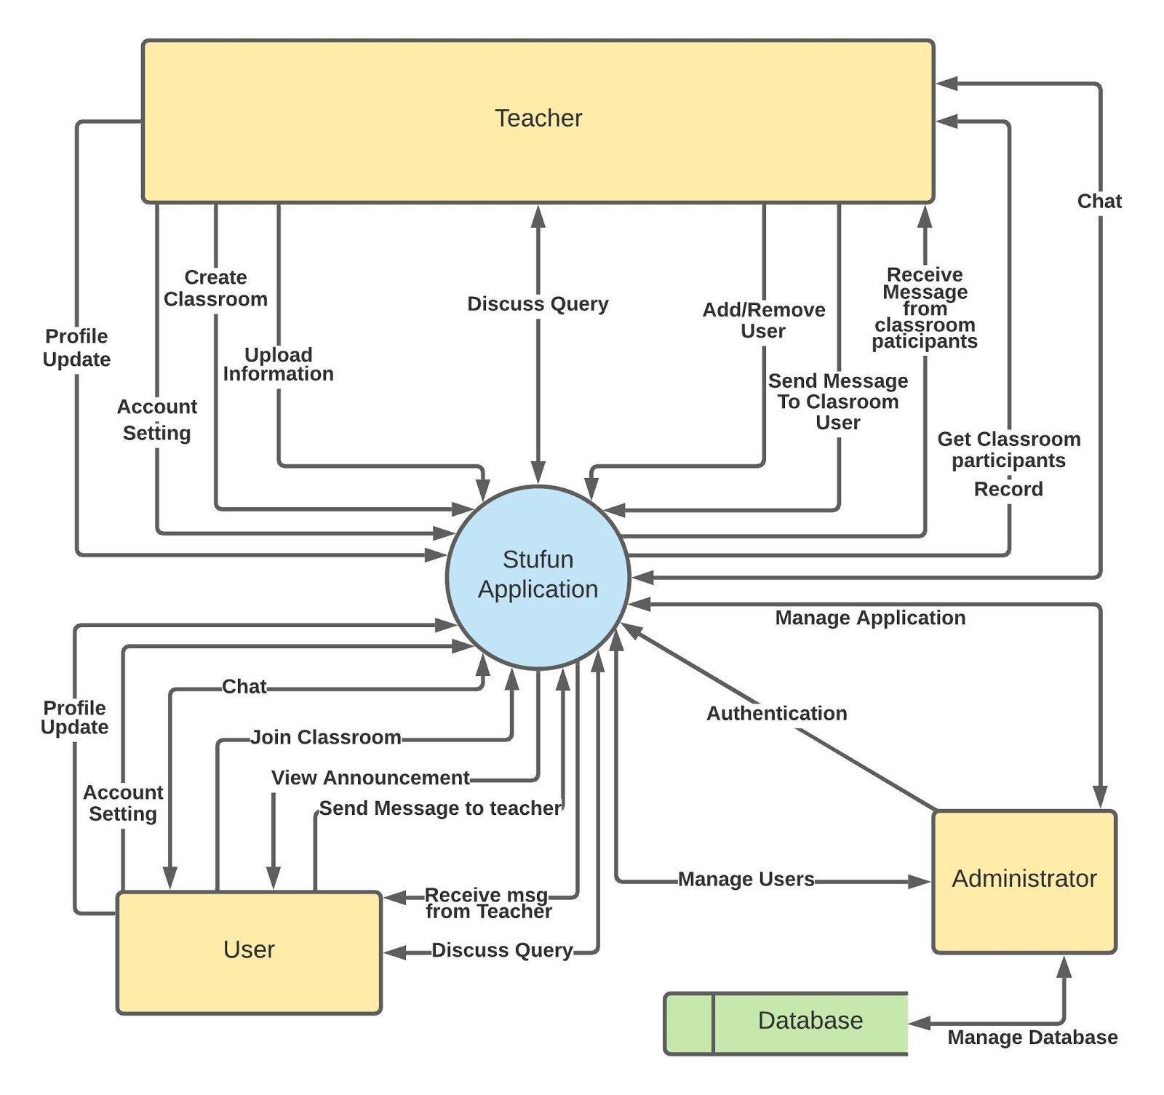

**3.2 UML DIAGRAM**

**3.2.1 CLASS DIAGRAM**

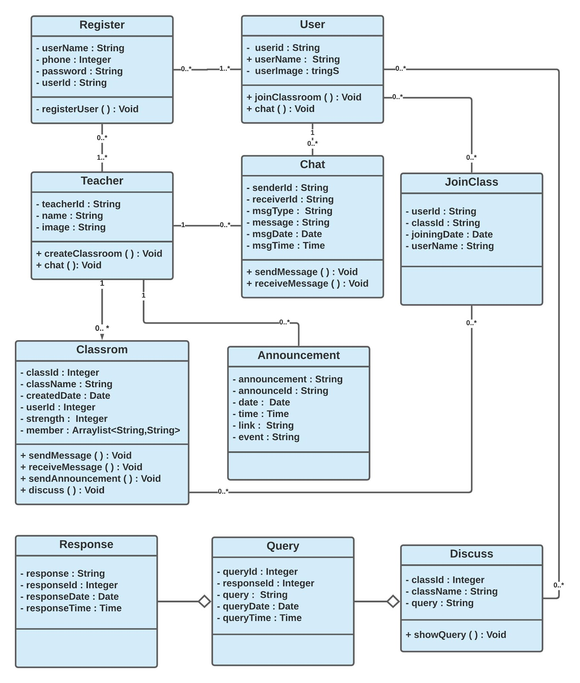

**3.2.2 ACTIVITY DIAGRAM**

**Registration/Login**

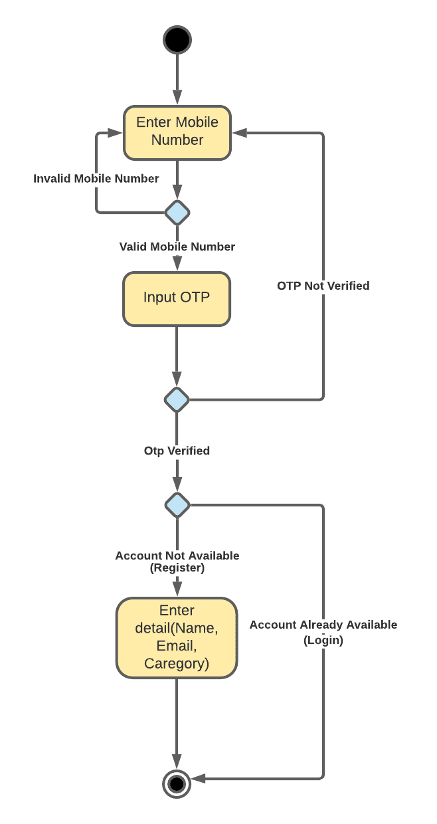

**Personal Chat**

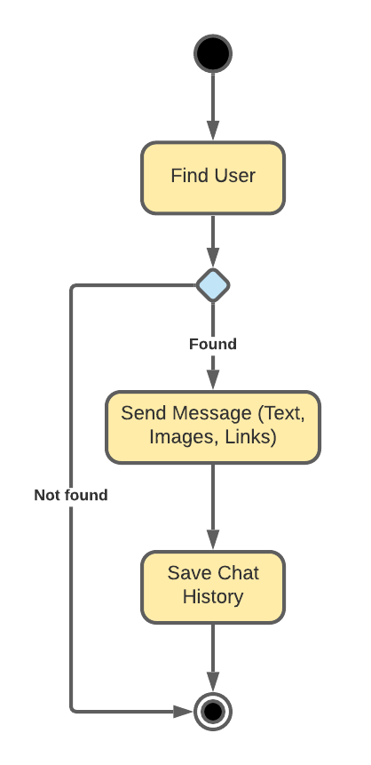

**Create Classroom**

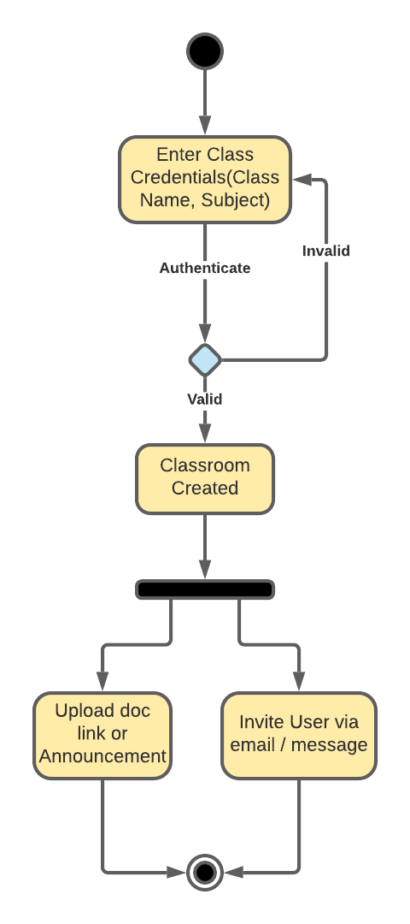

**Join Classroom**

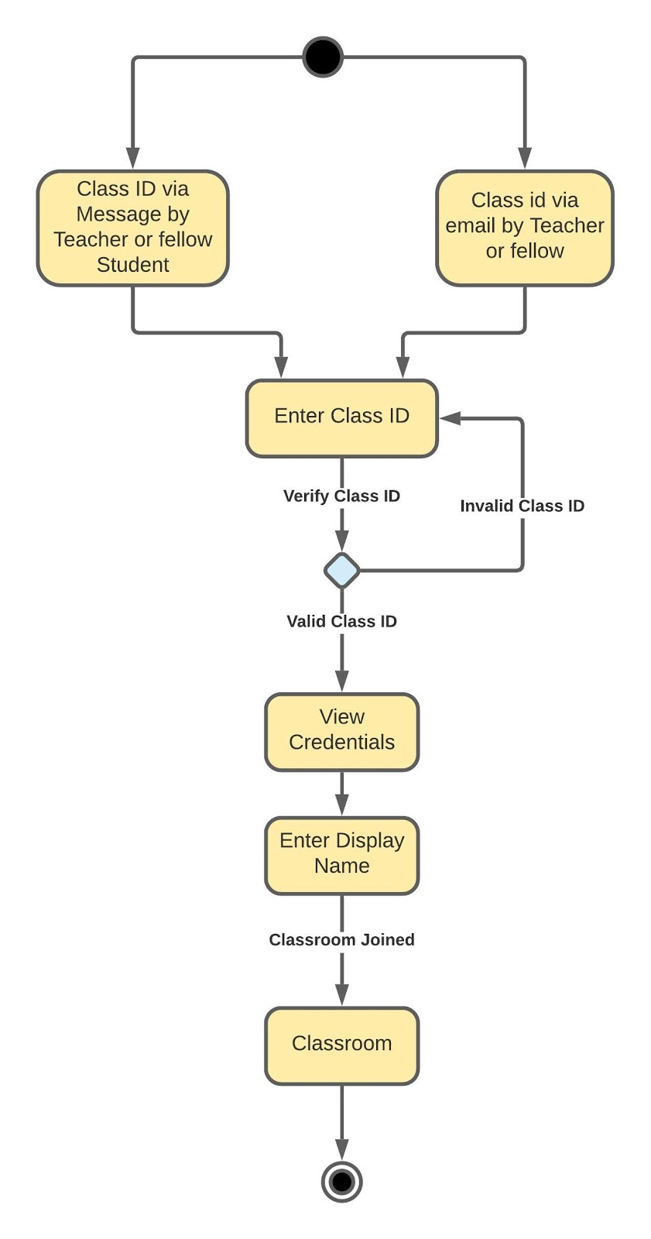

**Discussion**

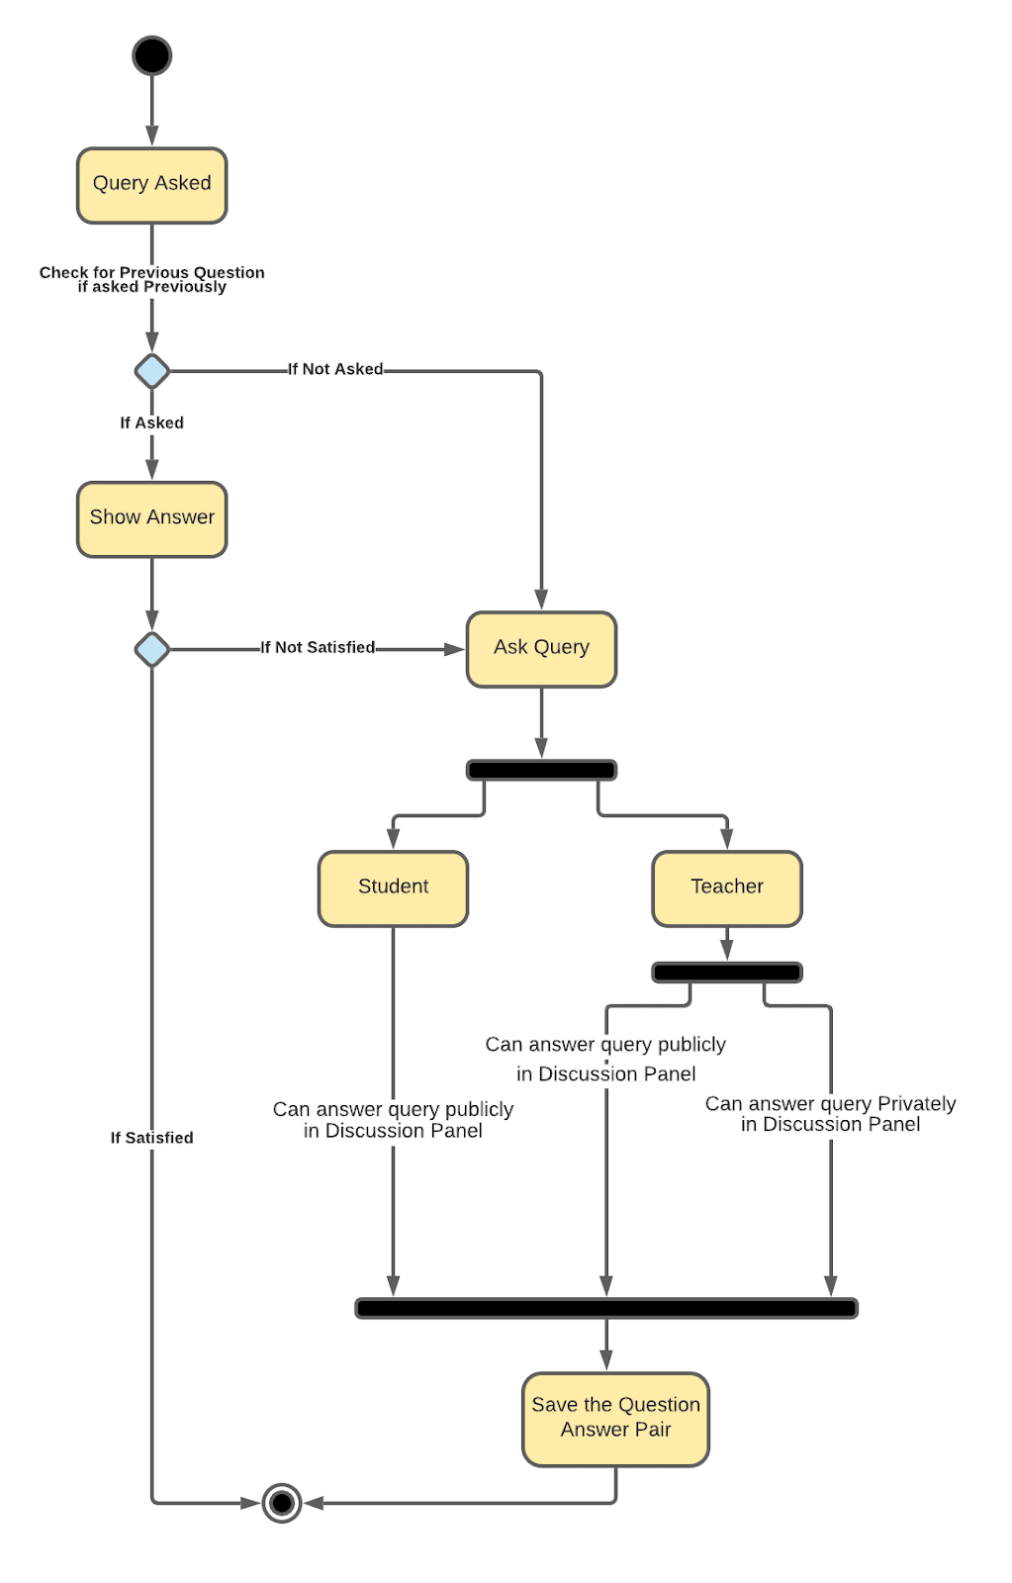

**3.2.3 USE CASE DIAGRAM**

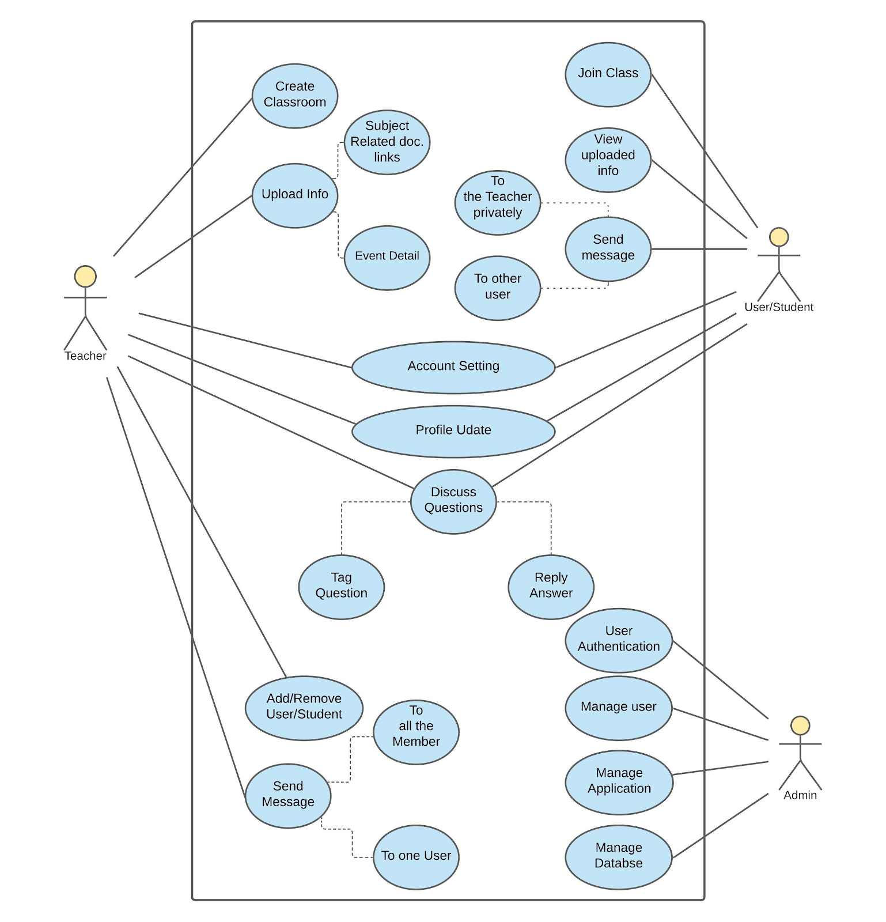

**3.3 DATABASE DESIGN**

**ER DIAGRAM**

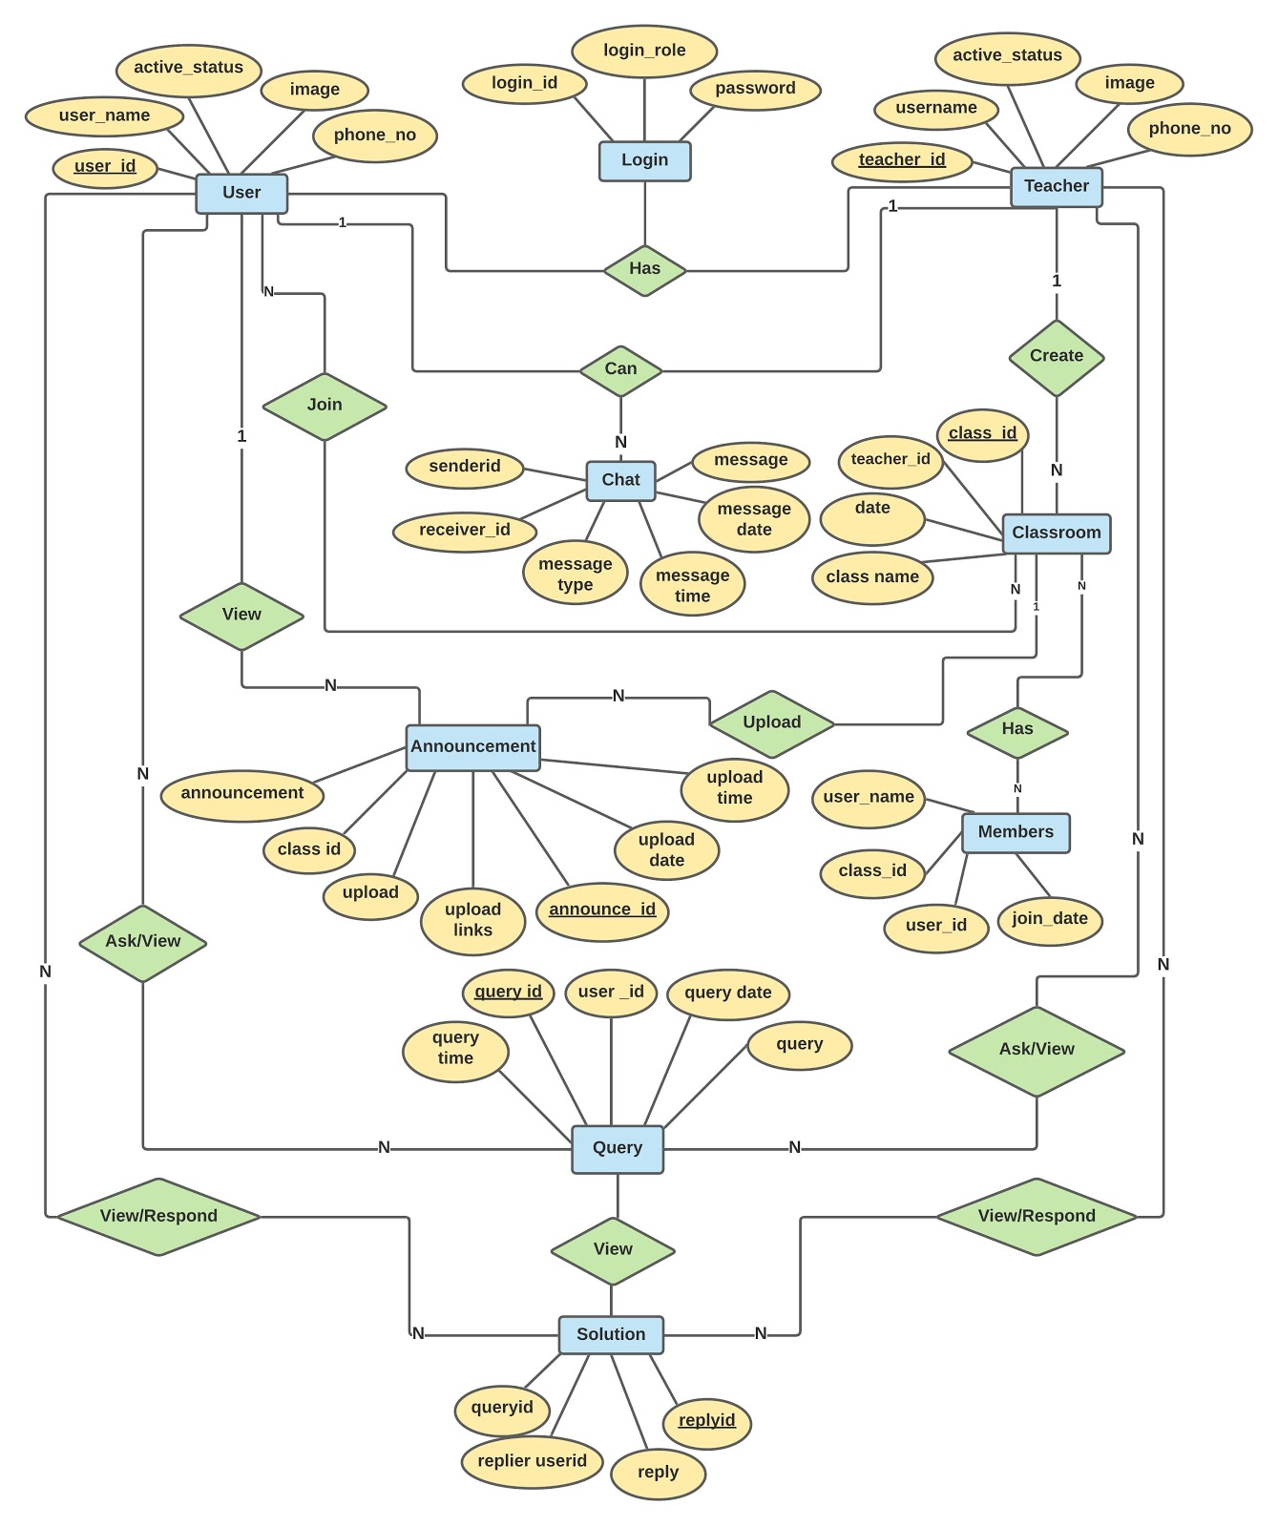

**DATABASE DESCRIPTION**

1. **Announcement**

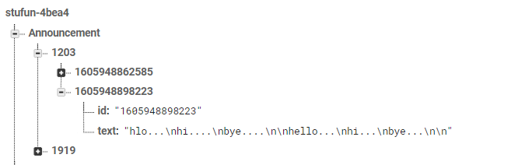

|  |  |
| --- | --- |
| Announcement table | |
| id | String |
| text | String |

1. **Classes**

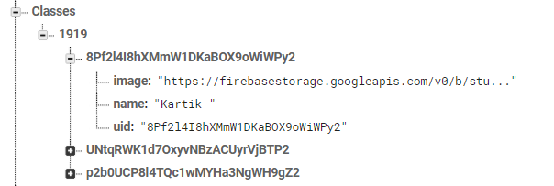

|  |  |
| --- | --- |
| Classes | |
| image | String |
| name | String |
| uid | String |

1. **Discussion**

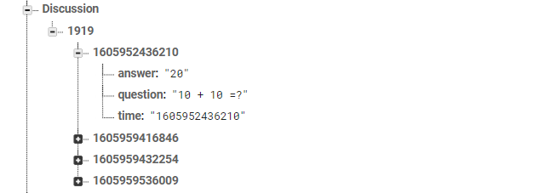

|  |  |
| --- | --- |
| Discussion | |
| answer | String |
| question | String |
| time | String |

1. **Token**

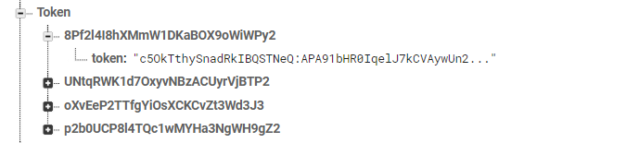

|  |  |
| --- | --- |
| Token | |
| token | String |

1. **StudentClass**

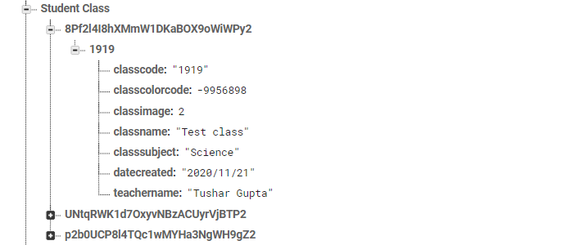

|  |  |
| --- | --- |
| Student Class | |
| classcode | String |
| classcolorcode | int |
| classimage | int |
| classname | String |
| classsubject | String |
| datecreated | String |
| teachername | String |

1. **Tclass**

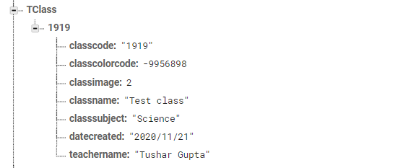

|  |  |
| --- | --- |
| Tclass | |
| classcode | String |
| classcolorcode | int |
| classimage | int |
| classname | String |
| classsubject | String |
| datecreated | String |
| teachername | String |

1. **TeacherClass**

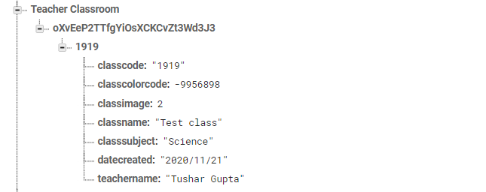

|  |  |
| --- | --- |
| Teacher Class | |
| classcode | String |
| classcolorcode | int |
| classimage | int |
| classname | String |
| classsubject | String |
| datecreated | String |
| teachername | String |

1. **UserChat**

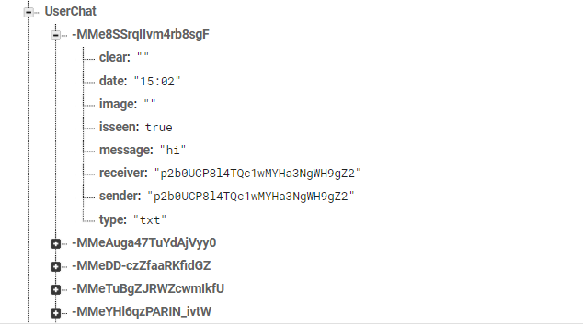

|  |  |
| --- | --- |
| UserChat | |
| clear | String |
| date | String |
| image | String |
| isseen | Boolean |
| message | String |
| receiver | String |
| sender | String |
| type | String |

1. **Users**

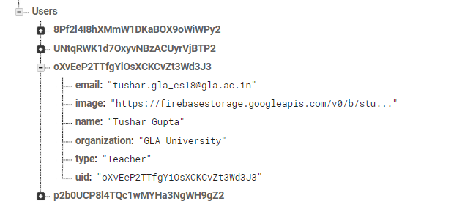

|  |  |
| --- | --- |
| Users | |
| email | String |
| image | String |
| name | String |
| organization | String |
| type | String |
| uid | String |

**IMPLEMENTATION AND USER INTERFACE**

**USER AS A TEACHER**

1. **Signup**

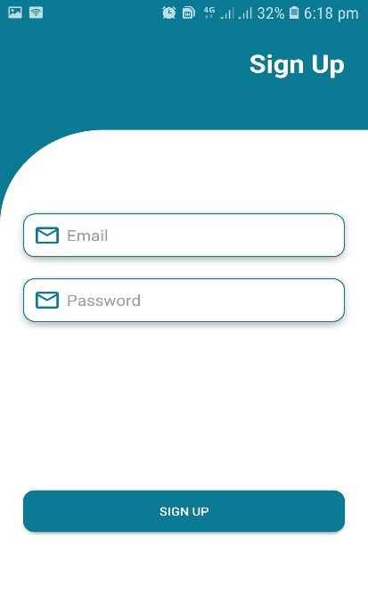

For sign up, we have use firebase authentication system. During signup user will ask for email id and password. After validation it will send a verification code to a user given id. After successful verification user refers to the profile creation activity.

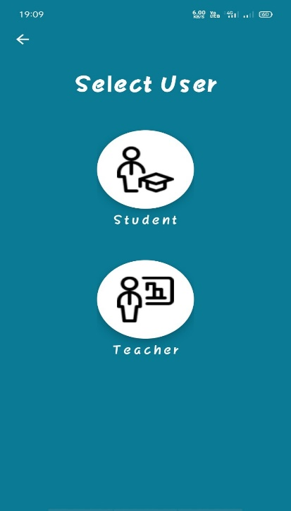

After verification user has to select the account type that is Teacher account for teacher and Student account for the student.

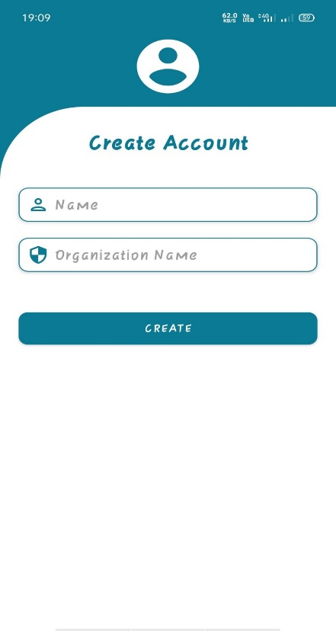

The teacher will be asked for an image, name, and Organization name. If any one of the details is not present then it will show an error.

1. **Login Activity**

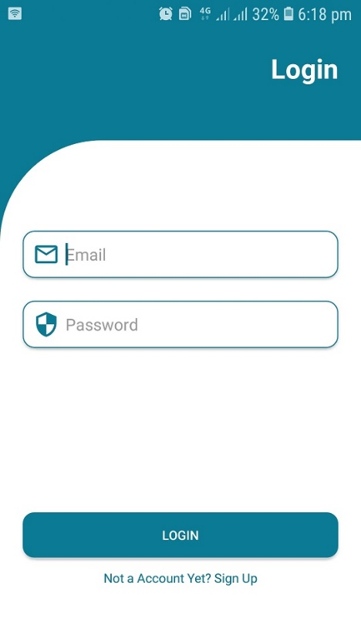

Login activity will ask for email and password. if both the things are matched it get access to the user to the application otherwise it will show a valid error message.

1. **Teacher Home Page**

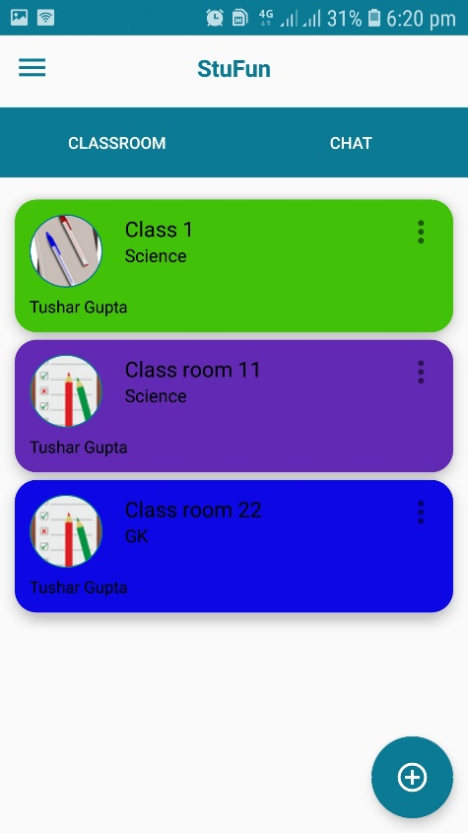

On the home page, the teacher can view a list of all the class that are created by him.

He can also create a new class by simply click the floating action button situated at the bottom-right corner

1. **Create Classroom**

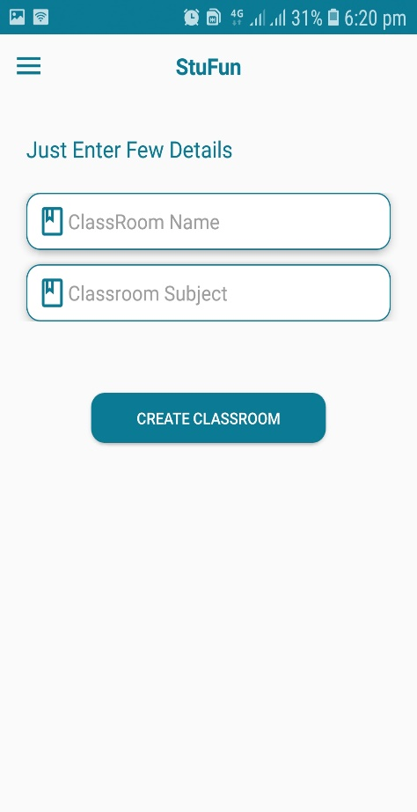

Teacher has to fill some necessary details such as Class name and Class room Subject to create a class room

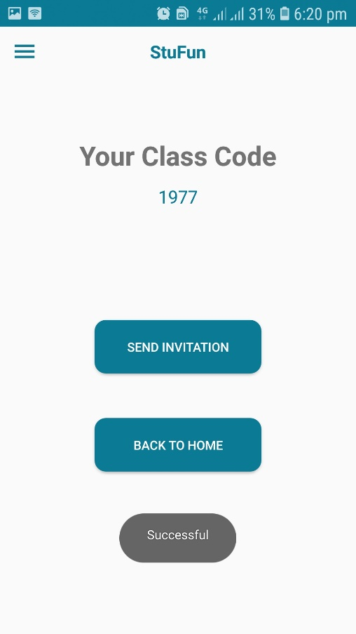

After validation, the teacher will receive a unique class code which is further used by the student to join the classroom. On the same activity, he has the option to send an invitation to join the class via email and SMS using external intent.

1. **Announcement Activity**

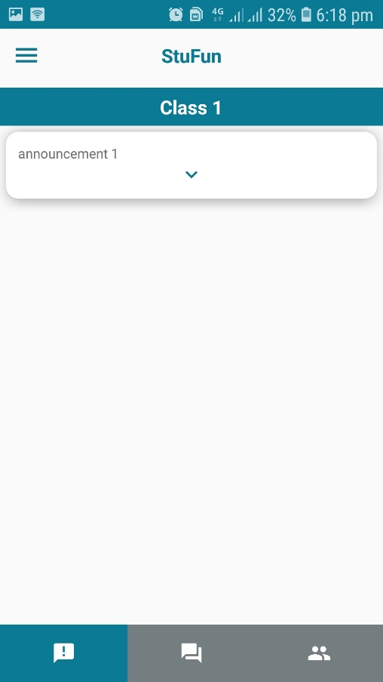

In this fragment, the teacher can view all the announcements which are made by him for the students. He can also delete an announcement by just simply right-swipe the particular announcement which is want to delete.

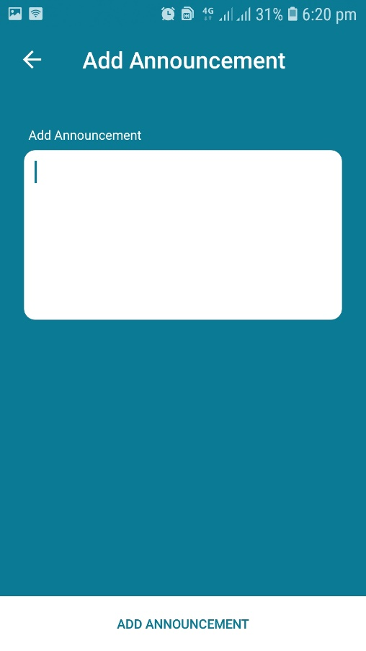

Teacher can easily add as many as announcement as he wants to add to a particular classroom.

After click add announcement the announcement gets added to the announcement recycler view of that particular classroom.

1. **Discussion Activity**

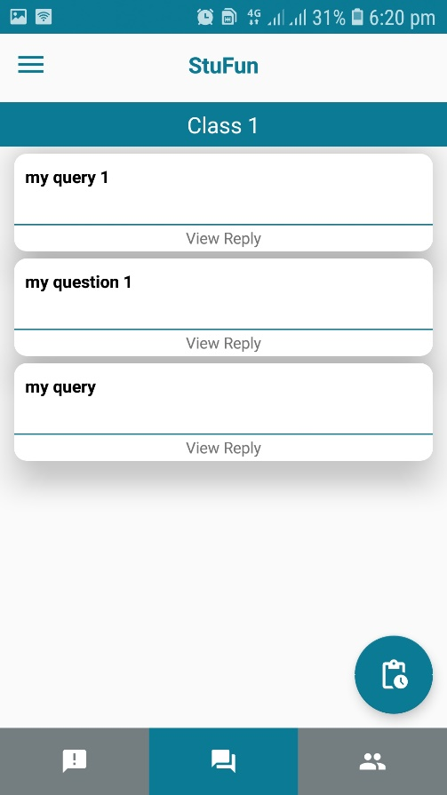

In the discussion, the fragment teacher can view all the previously asked queries with their answer as well as a pending query button.

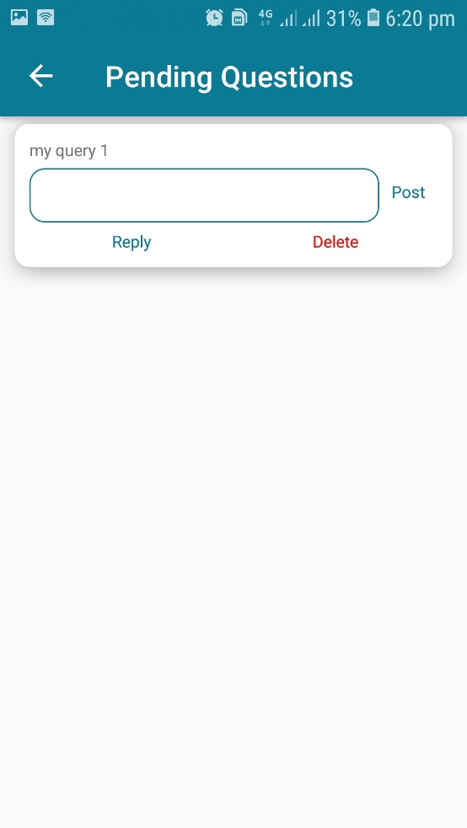

Pending question activity contains a list of all the queries that are asked by the student and does not been answered by the teacher yet.

Here teacher has 2 options, either he can reply and post the query or he can delete the query.

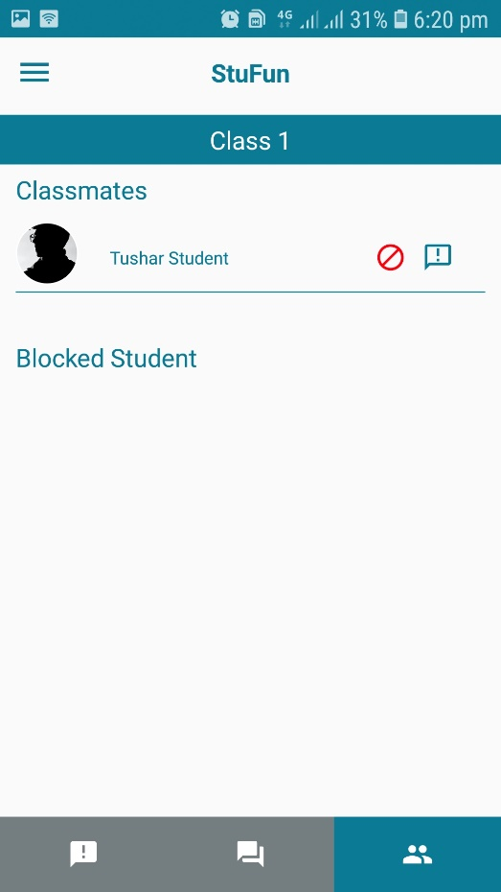

Teacher can details of all the student. Teacher can block the student from that particular class and also message him directly from here.

1. **Chat Activity**

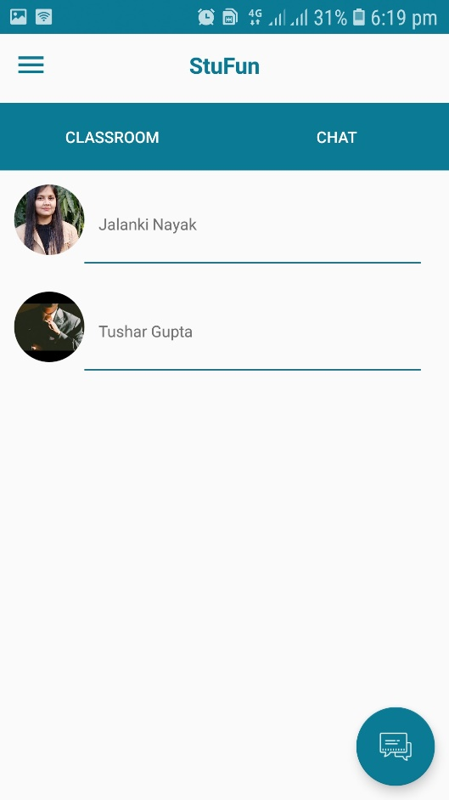

User can view a list of all the user with whom he has previously some chat.

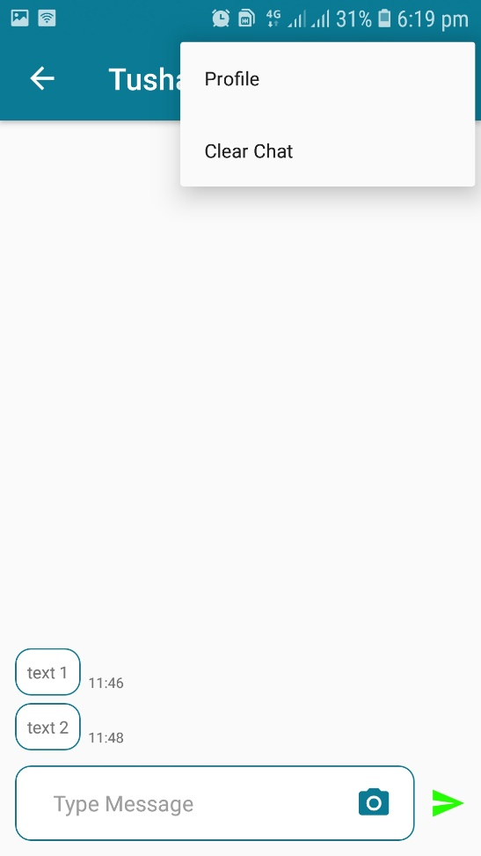

User can send a text or image message to another user.

At the bootom of the last message a “seen” mark indicates wheather a receiver has seen a message or not.

Top menu bar contains 2 option –

1. Profile – From where he can view the detail of receiver.
2. Clear chat – From where user can clear the chat.
3. **Setting Activity**

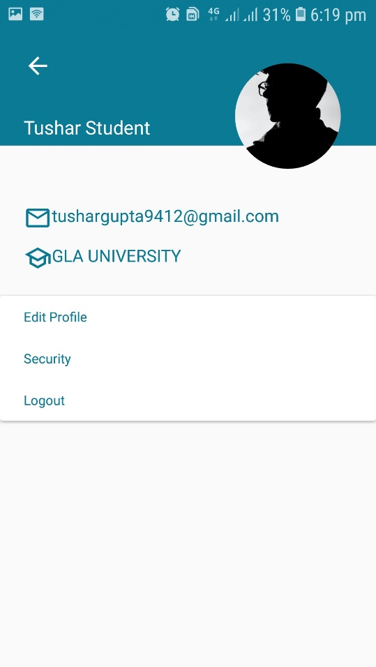

Setting Activity shows the profile detail and shows the option to change the profile details

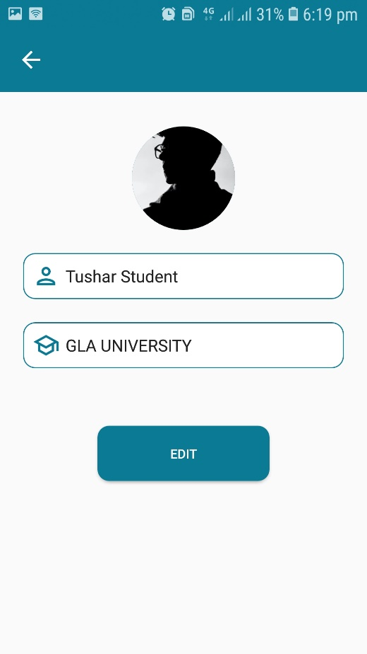

Edit Profile Activity allow user to change details such as name and organization.

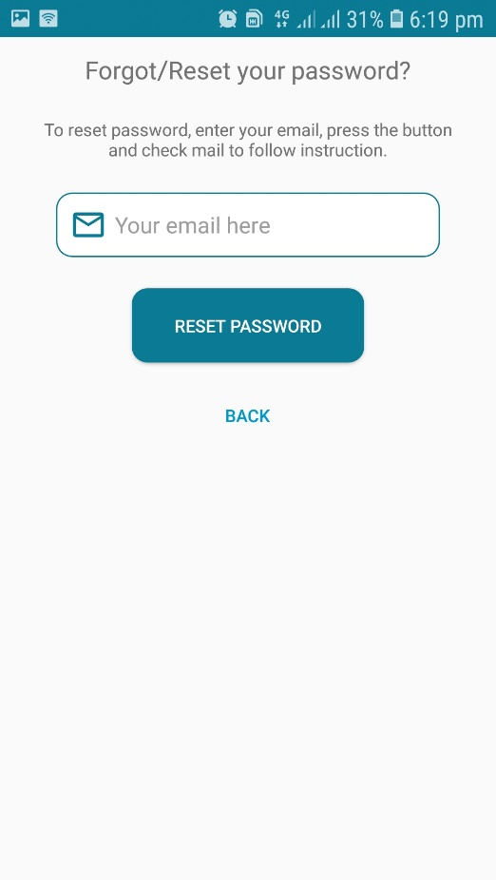

In the security section user can change their password.

User will receive a password change mail to the given email id. after successfully registered a valid password user can login into their account with their new password.

**USER AS A STUDENT**

1. **Signup**

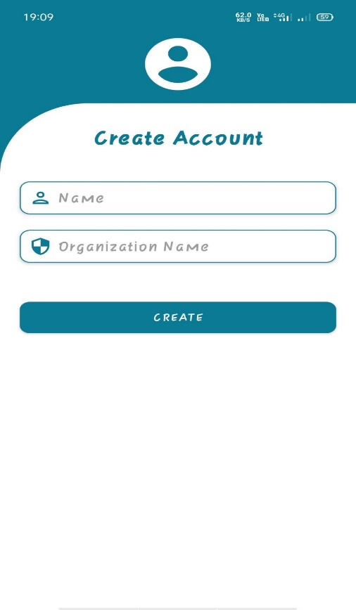

Sign up procedure for student is same as teacher except profile detail entry. During profile creation it will asked for branch and couse also along with name, image and organization.If the details are not valid then it will shows an error.

1. **Student home**

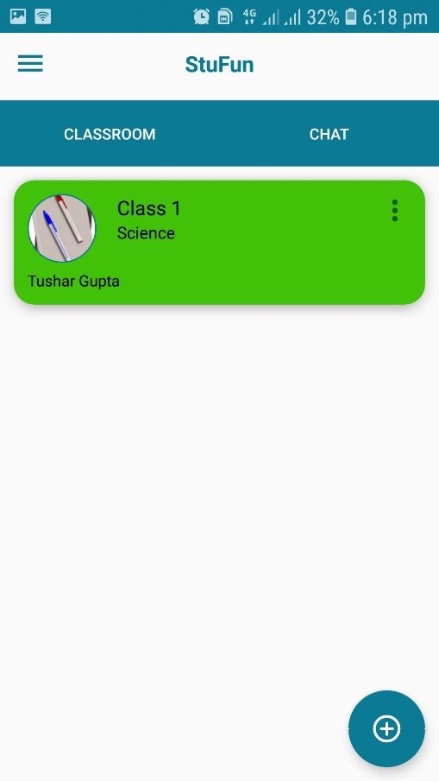

On the student home page, student can view a list of joined classroom.he can also unenroll from the particular class as well as join new class.

1. **Join Class**

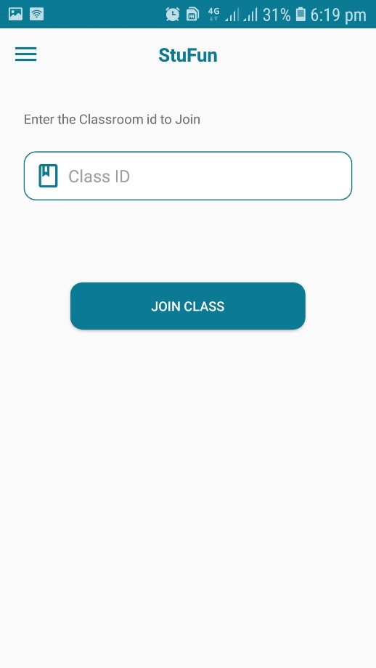

Student can join a classroom by entering a 4 digit unique code given to him by the teacher,

1. **Announcement Activity**



Student can view a list of all the announcements made by teacher which keeps him updated.

1. **Discussion Activity**

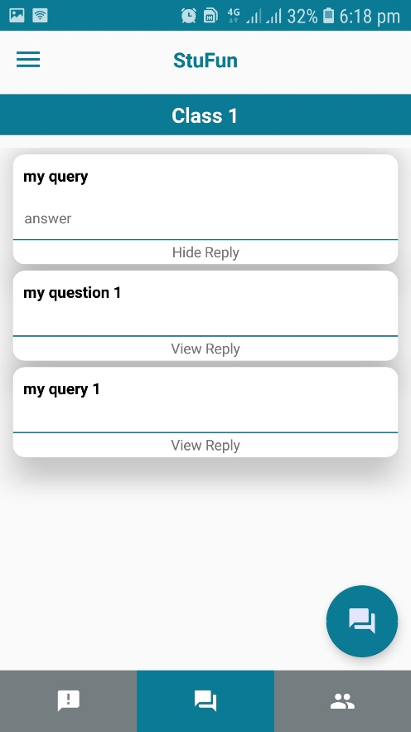

Student view a list a all the previously asked query along with its answer.

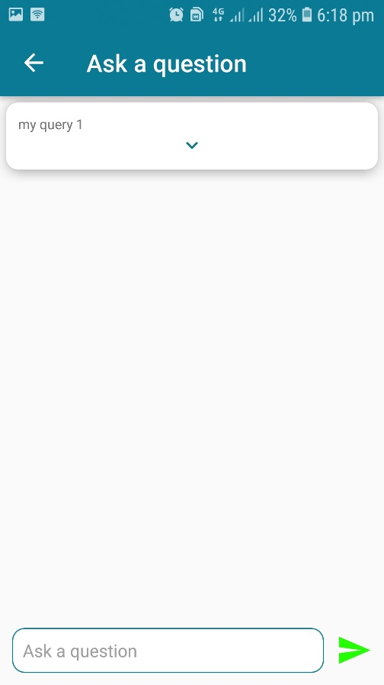

Student can ask a query and all his unanswered query will be stored in pending question datalist until it is replied or deleted by the user.

1. **Classmate Activity**

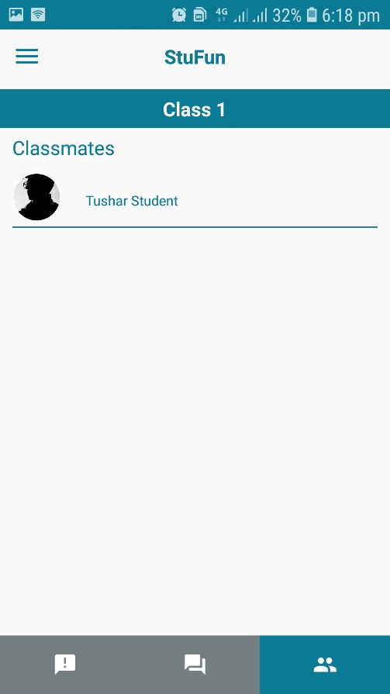

Student view a list of all there classmate of that particular classroom.

# **REFERENCES**

* + - * <https://en.wikipedia.org/wiki/Android>
      * <https://en.wikipedia.org>
      * [www.coursera.in](http://www.coursera.in)
      * <https://stackoverflow.com>
      * [www.firebase.in](http://www.firebase.in)